Accessible Communication Devices / Supports at HDSHRC
Image | Name | Description
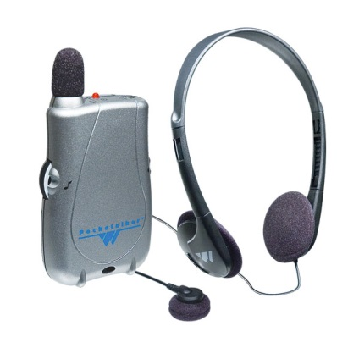 | Pocket Talkers | Personal hardwired amplifiers that amplify sounds closest to the listener while reducing background noise.
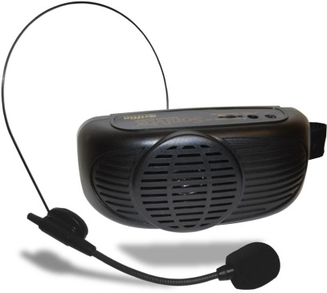 | Voice Amplifiers | A device that amplifies or increases the volume of the voice of an individual.
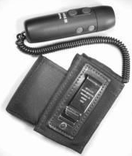 | Electrolarynges | A medical device used to produce clearer speech by those who have lost their original voicebox.
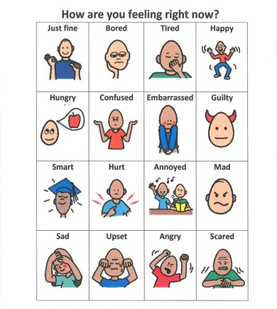 | Communication Books / Boards / Wallets | Consist of photographs, symbols, and/or words/phrases to address vocabulary needs in a visual format.
 | Wallet Cards | Small versions of a communication board, or a sentence that describes how to best communicate with a person.
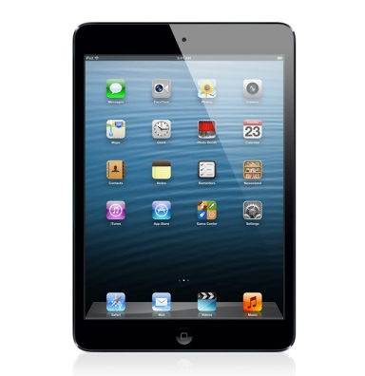 | iPads | Handheld electronic displays that can produce spoken words (from typed text) or produce and display communication boards.

